**EC2 APP HOSTING**

1. Create instance for windows:

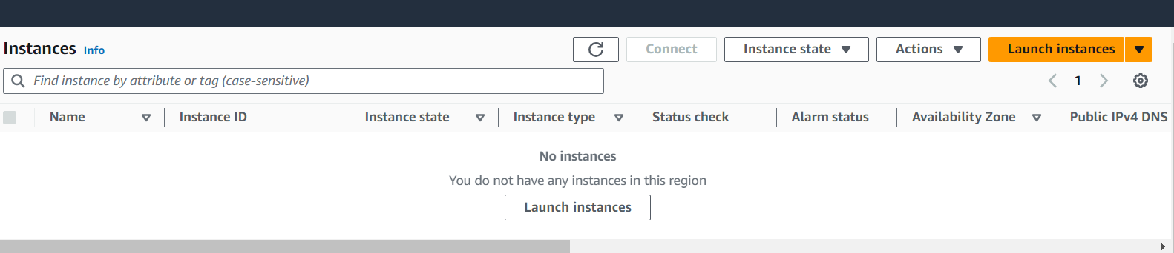

1. Click launch instance
2. Give name and select the ami as windows

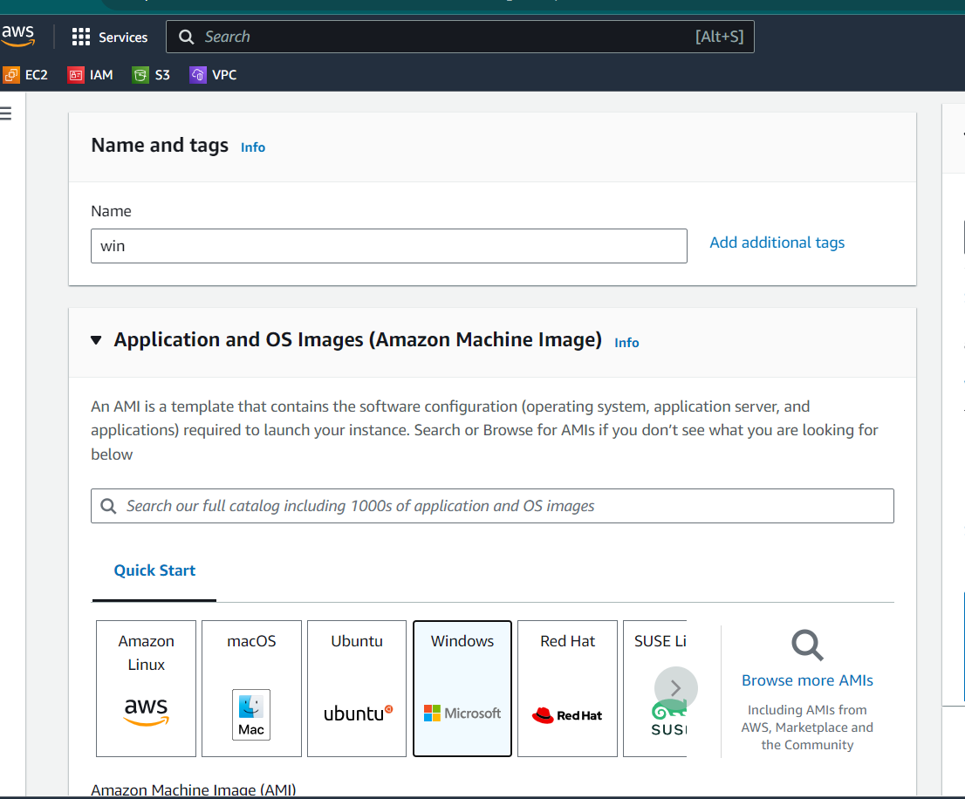

1. Create a new key pair

* Give a name to key pair
* Select .pem key
* The key pair will be downloaded in files

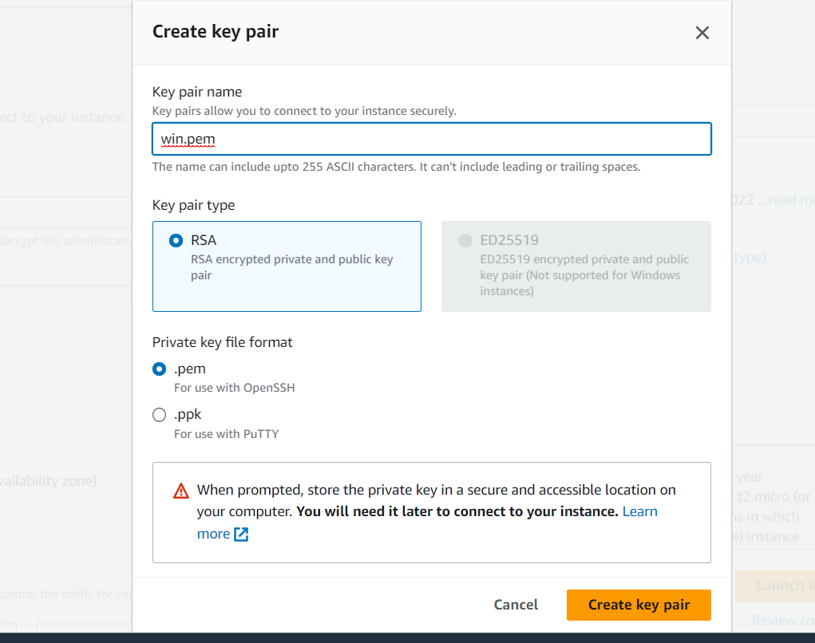

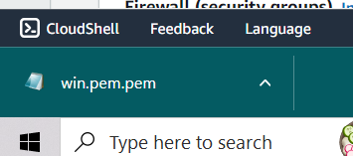

1. Select allow http protocal
2. Click launch instance.

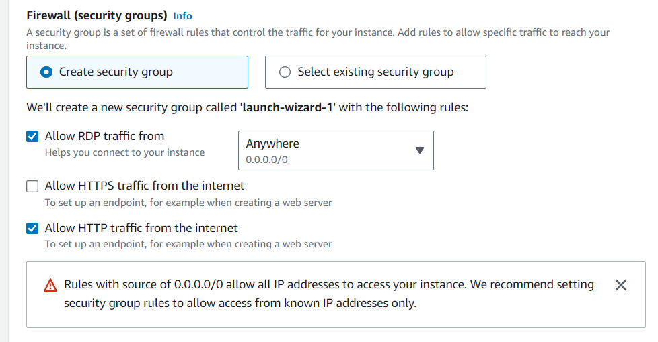

1. Create a instance for linux
2. Click launch instance
3. Give name for linux server and the ami as amzon linux

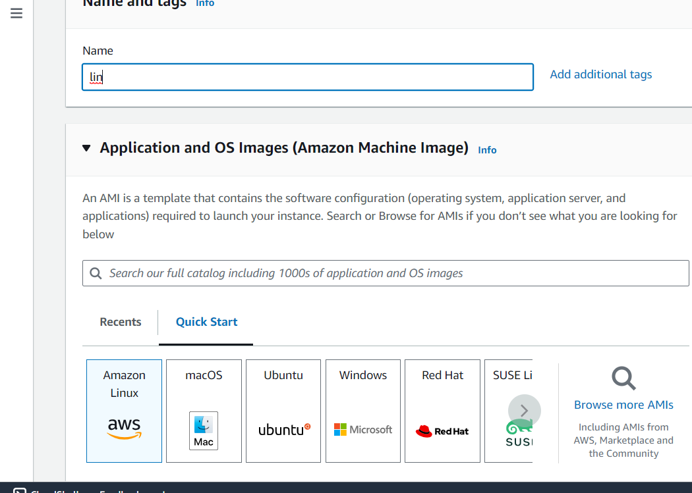

1. Create a new pair for linux server

* Give a name for key and select .ppk and click create keypair
* The ppk file will be downloaded

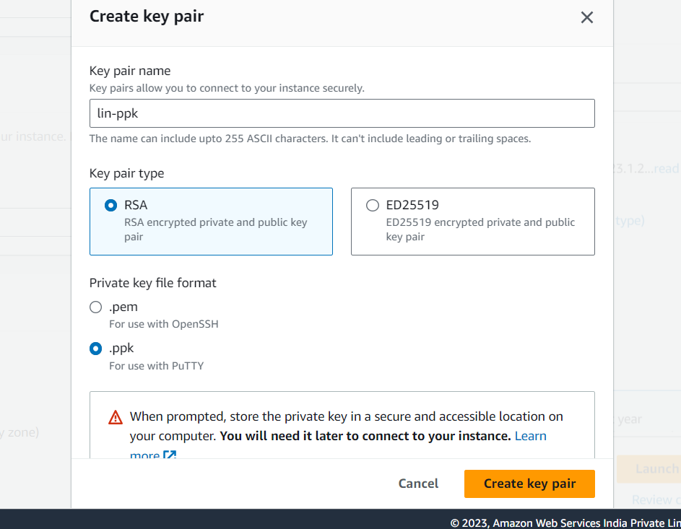

1. Select allow http protocal and click launch instance

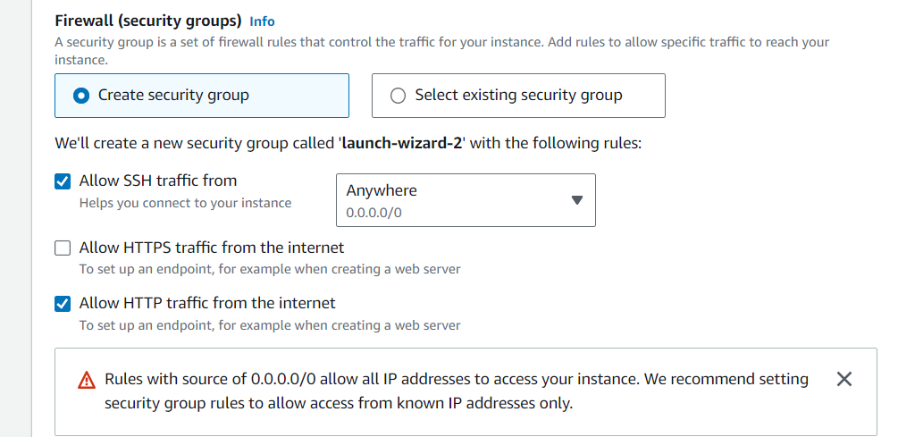

1. Instances created for both windows and linux

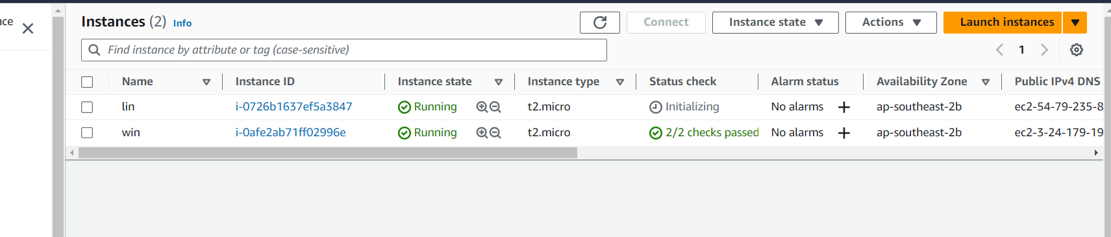

1. Get the host name ,user name and get the password by uploading .pem key pair file and decrypt the password .

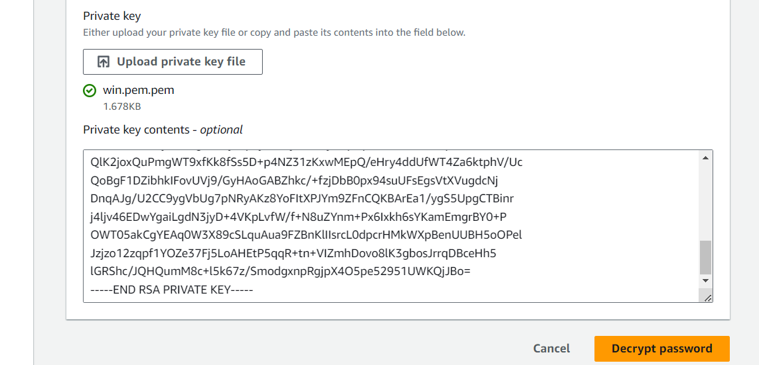

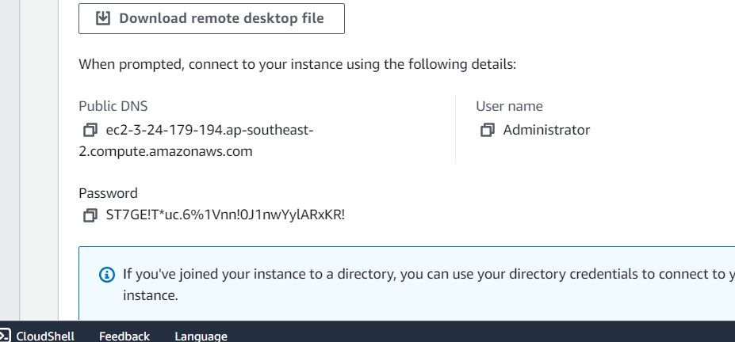

1. Windows server installed

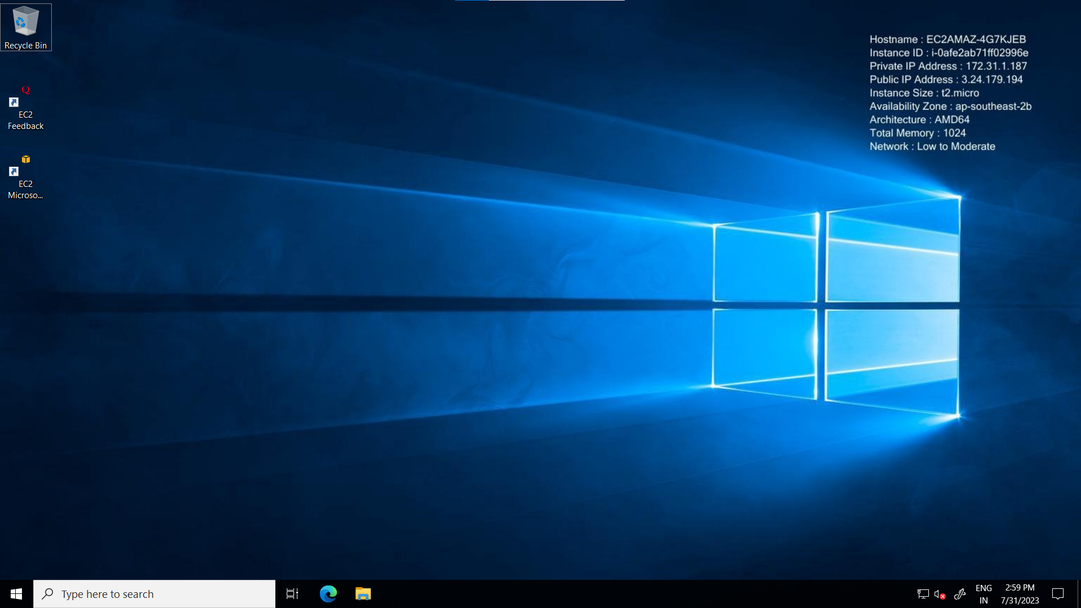

1. Get the public IP address as host name and upload the .ppk private key file in SSH🡪 AUTH🡪 CREDENTIALS and login into linux server as ec2 -user.

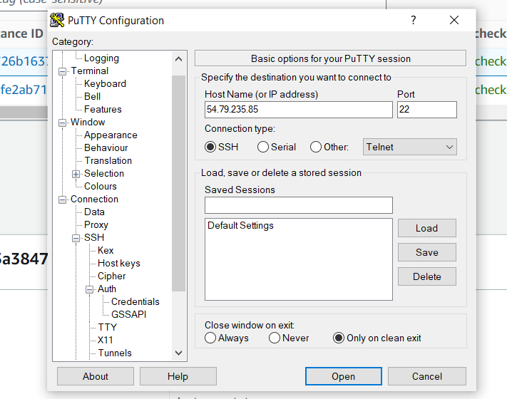

1. Open the file and select accept

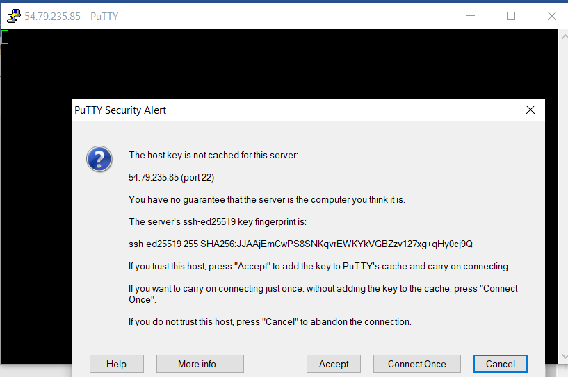

1. Linux server installed.

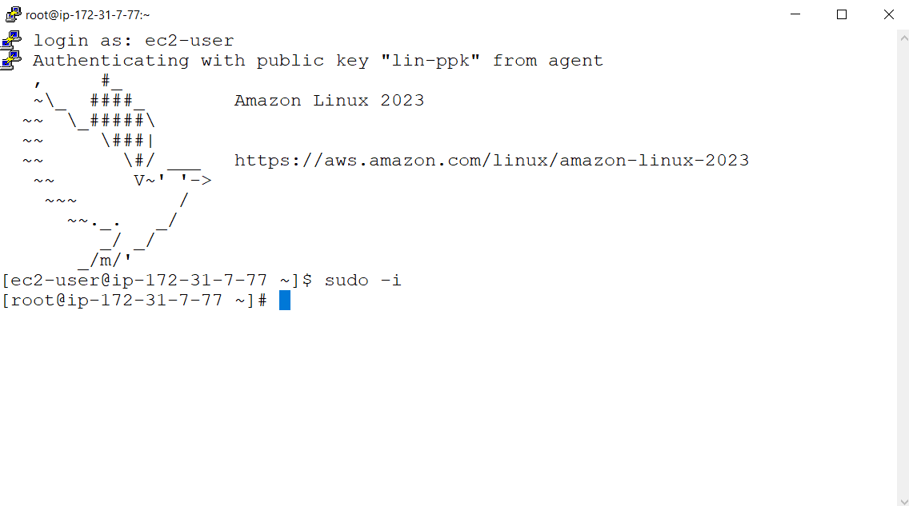

1. Open the installed windows server and install middleware
2. Go to windows 🡪 server manager 🡪 Add roles and features 🡪 server roles 🡪 web server IIS 🡪 add features 🡪 Install.

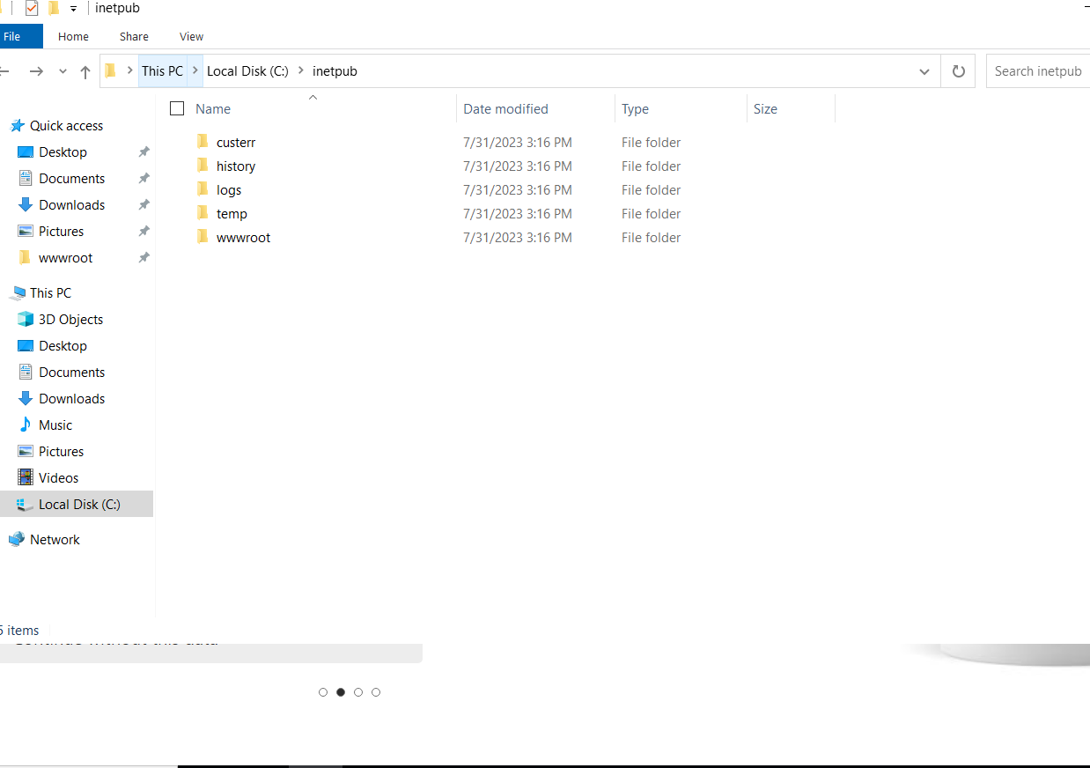

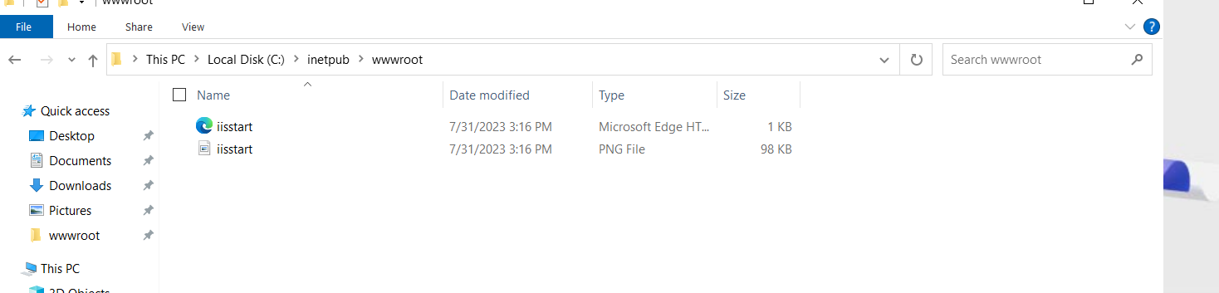

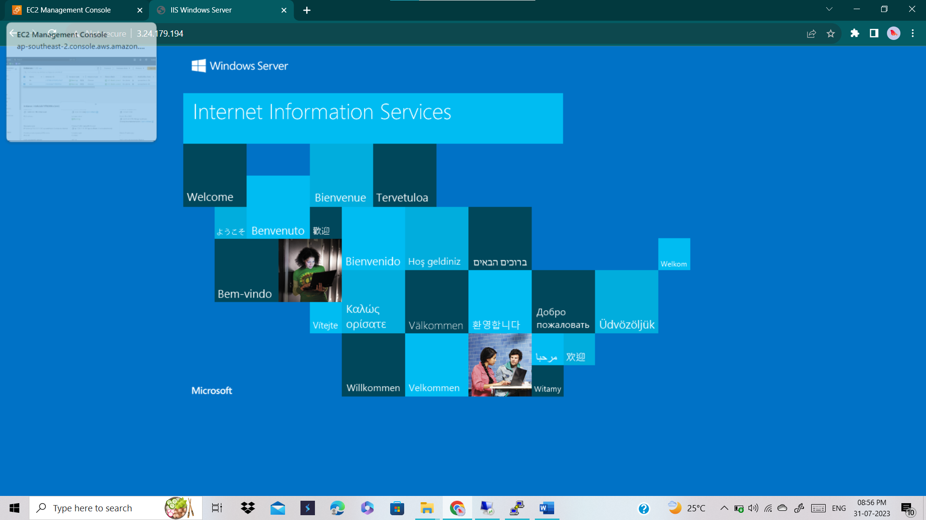

1. Deployment process finished in windows server and the result is given below

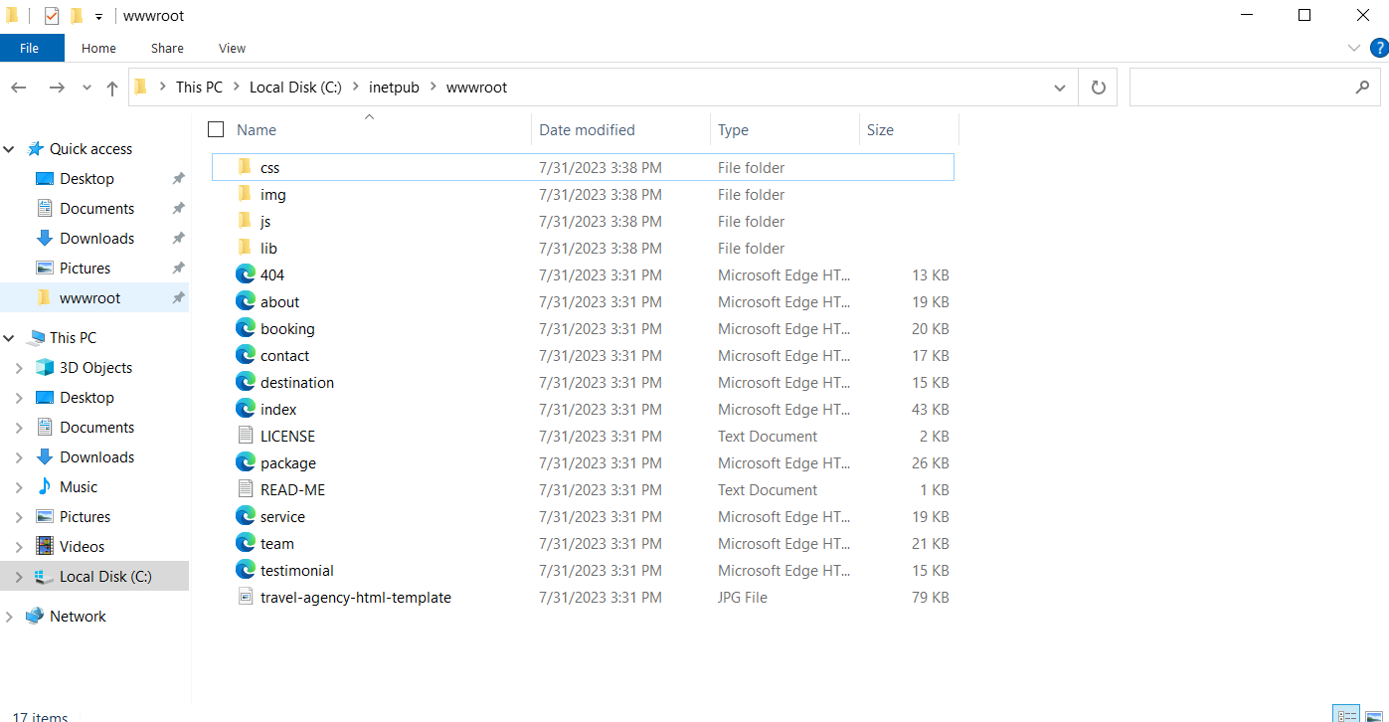



1. Deployment process in linux server

* Update yum
* Install middleware using yum install httpd(appache)

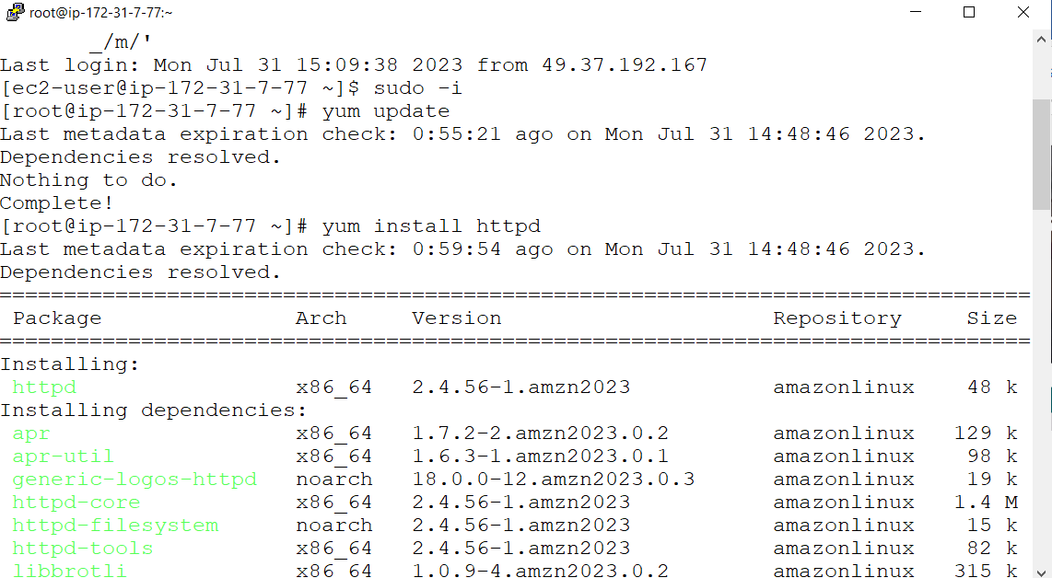

1. Yum updated and installed middleware

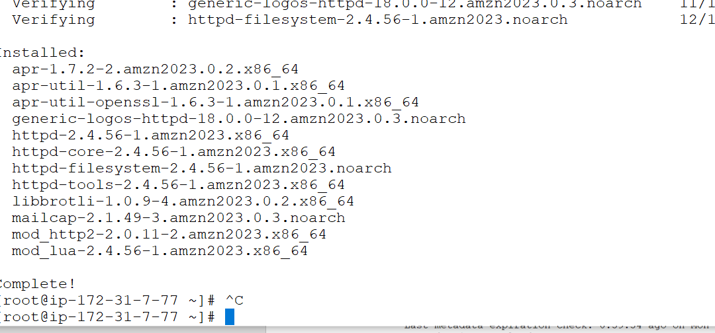

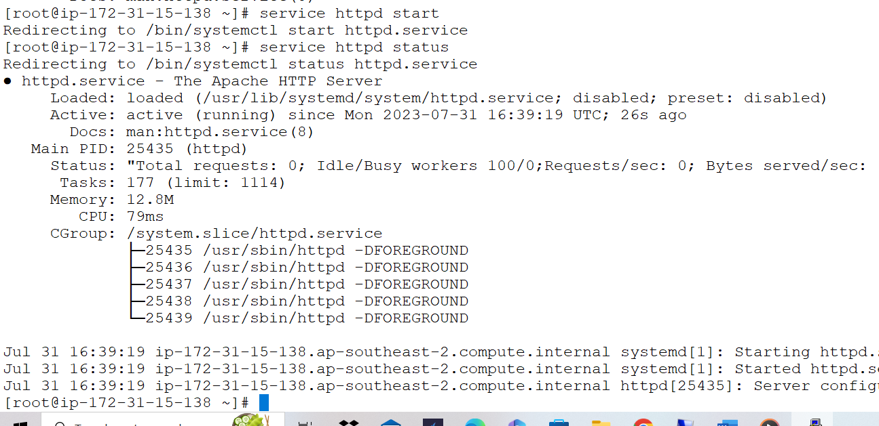

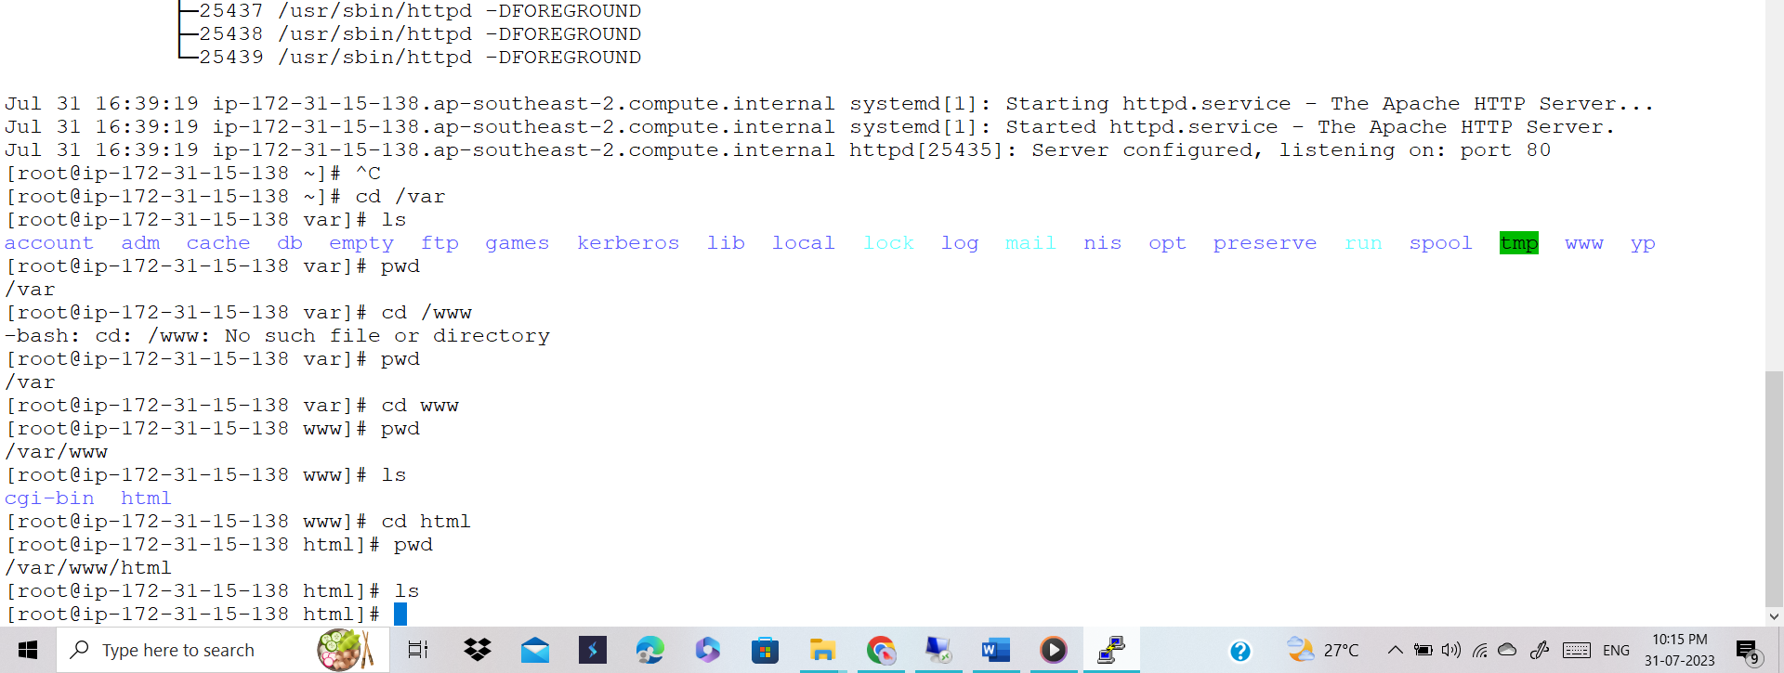

1. Downloaded winscp and pasted the static code file in /var/www/html

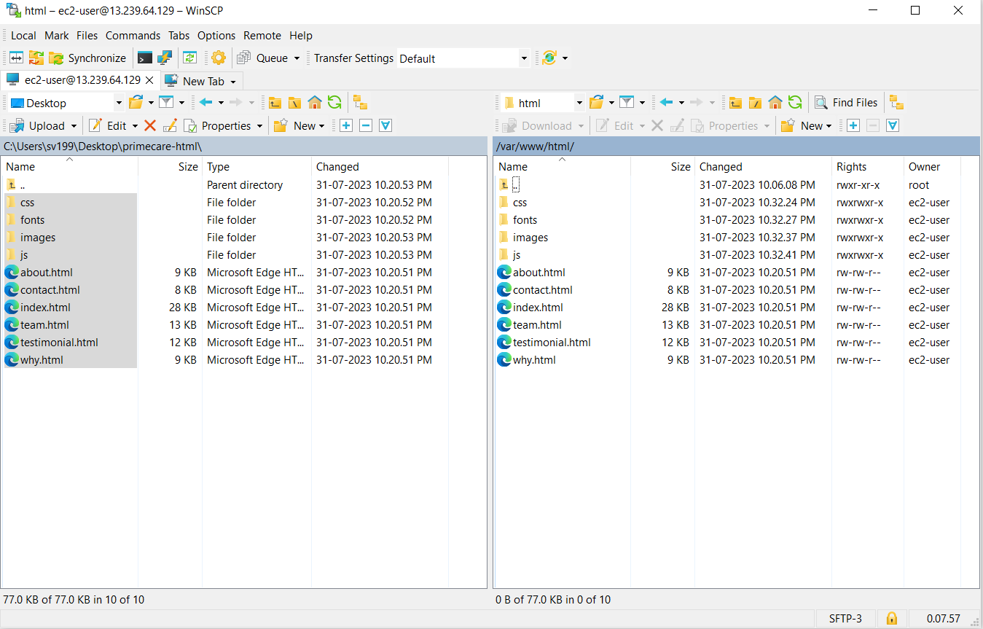

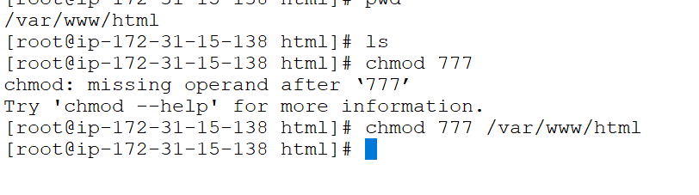

1. Deployment process done in linux server.

